November 1, 2020

Peacock Law P.C.’s paralegals are world-class, impressing clients and other lawyers around the world with their attention to detail. We are proud to have such experienced and knowledgeable paralegals, and we would like you to know who they are, starting with Diane Nelson, our Paralegal Coordinator.
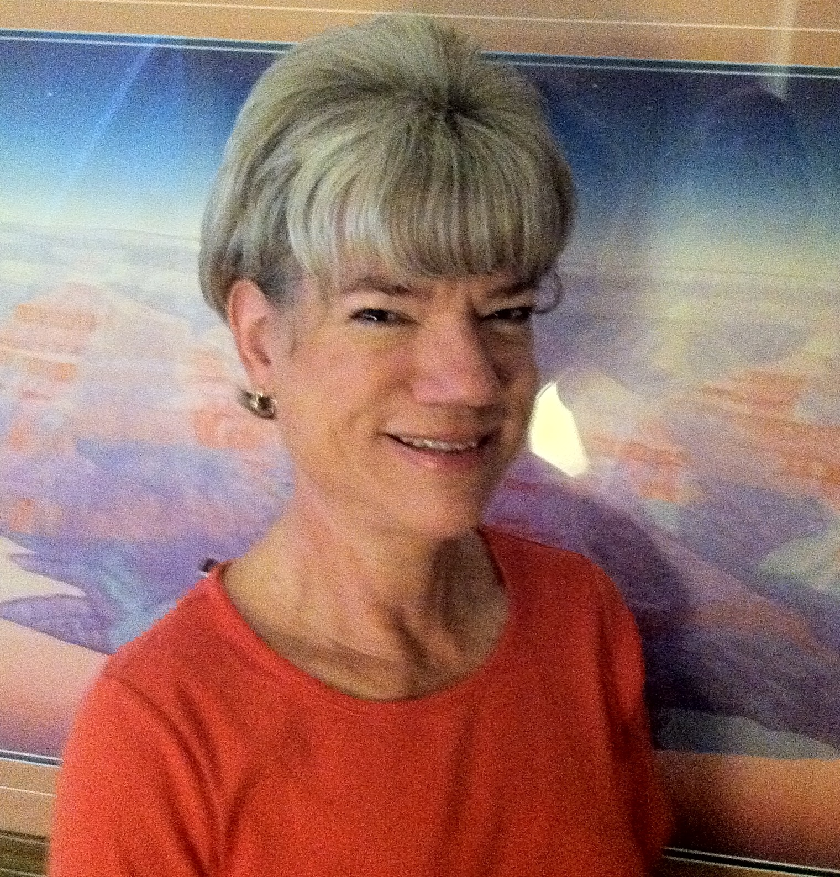

Diane is responsible for paralegal training and directs the challenging task of keeping our filing procedures up to date with the ever-changing requirements of the various government agencies. Having been with Peacock Law for over 25 years, she is a true master in all the legal and technical details required for intellectual property filings. She started with the firm as receptionist/bookkeeper/office manager, and then was bitten by the paralegal bug while assisting one of the paralegals with client correspondence and filings. She has been helping the firm as a paralegal since 2005, assisting with filing high value, high stakes intellectual property, throughout the world.

Diane holds a Bachelor of Science Degree in French and Linguistics from Georgetown University, Washington, D.C., and also studied at the Sorbonne in Paris, France. Although raised in Pittsburgh, Pennsylvania (hence, her tremendous enthusiasm for the Pittsburgh Steelers!), Diane has lived in Albuquerque for nearly 35 years, and therefore considers herself practically a native of New Mexico. She is an avid road cyclist and many of her travels have been to pursue this passion, including recreational rides all over the Southwest, and cycling vacations on the rail trails of the East coast and to Tuscany, Italy.

In Other News…

In October, Albuquerque Business First recognized Peacock Law P.C. as one of New Mexico’s top-ten women-owned enterprises. We are proud to have had so many happy clients over the years to grow to this point of being a leading company in the state Much of this success is due to our world-class paralegal team led by Diane Nelson!

